Ontology Design on Breast Cancer Cause, Symptoms, Diagnosis, and Treatment

Gregory Brown, Sai Sri Narne, Priyanka Gaikwad, and Lakshmi Korrapati

*Department of Computer Science Electrical Engineering*  
*University of Missouri-Kansas City*Kansas City, USA  
gbkhv@ mail.umkc.edu, sn69k@mail.umkc.edu, pvg9gb@mail.umkc.edu, vkvn3@mail.umkc.edu

**Abstract—Ontologies were developed in Artificial Intelligence to facilitate knowledge sharing and reuse. Since the beginning of the nineties ontologies have become a popular research topic investigated by several Artificial Intelligence research communities, including Knowledge Engineering, natural-language processing and knowledge representation. In recent years, there has been explosive growth in the amount of biomedical publications. One such work is this paper that majorly deals with the designing an ontology based on various causes of breast cancer, Symptoms, identification of Cancer and methodologies used to identify the Cancer in breast cells in order to contribute a knowledge graph in reference to some of the existing ontologies.**

**Keywords — ontology, breast cancer, automated design Spark**

# I. Introduction

As there is an increase in number of diseases, patients, Biomedical data has begun to use Big data for all its unstructured data to store, retrieve, and use. Big data applications present new opportunities to discover new knowledge and create novel methods to improve the quality of health care. Since then there is a major rise in amount of Biomedical Publications and Biomedical research. But, it is difficult to relate the biomedical findings to a doctoral decisions for a medicine and treatment. The most up-to-date findings about diagnoses, interventions, and treatments would be important when attempting to make critical decisions for patients by physicians and researchers in health care. This drove in developing various methods and tools in the area of database integration, using an ontological approach. In this paper the major work focuses finding with in a large number of documents embedded into a corpus.

# II. Related Works

Many works have been proposed to create ontologies and their application from a medical corpus. Oshani et al.[4] proposed a prototype system which uses semantic technology approach,which is based on automatic parsing of data from AJCC staging manuals.They have included additional biomarkers which are present in revised 8th edition of AJCC Cancer Staging Manual. The mapping of breast cancer terms to community accepted terms from the National Cancer Institute thesaurus(NCIt) is included as part of ontology creation.

In this work they have considered staging criteria from AJCC 7th edition and AJCC 8th edition to construct Inference agent. The map files which are extracted corresponds to staging criteria specified in AJCC staging manual. For calculation of Inference agent it has not considered the narrower stages specified in AJCC staging manual.

# III. Proposed Work

There are following areas which are focused in our Breast Cancer ontology work.

* Symptoms
* Causes
* Diagnosis
* Treatment Plans

The process of generation of Ontology has following steps which are executed sequentially:

1. Information Extractoin:

1. Retrieval of abstracts:

There is lot of research work done on breast Cancer by biomedical Scholars and how to integrating results from biolabs to digitalized form, where each of their is of their work is published in the form of some research paper. Here considering such text from these publications processed data for ontology creation. We use PubMed search engine [8] in the Scala code to retrieve PubMedID accordingly to obtain data set of abstracts. NLP actions are performed on this data.

b. Natural Language Processing (NLP):

This is used to process and analyze large amounts of natural language unstructured data. Following processes are conducted as a part of NLP.

* 1. Tokenization is the process of identifying individual words, numbers, and other constructs.
  2. POS Tagging assigns each word in a sentence its respective part of speech such as noun, verb or adjective.
  3. Named Entity Recognition identifies entities such as persons, locations, and times within a text corpus.

Example sentence: Breast cancer patients were identified from the Taiwan Cancer Registry (2002-2014). Following is the dependencies tree for this sentence.

|  |
| --- |
| **Algorithm1** |
| **Ontology_Construction**()  {  Abstracts = **RetrieveAbstracts**(PubMedIDs)  CoreNLPResults[] = **StanfordCoreNLP**(Abstracts)  NER = CoreNLPResults[1]  Triplets CoreNLPResults[2]  BioMedical_Objects = **BioNLP**(Triplets.objects)  BioMedical_Subjects = **BioNLP**(Triplets.subjects)  Subject_Synonyms = **WordNet**(Triplets.Subjects)  Object_Synonyms = **WordnNet**(Triplets.objects)  Subject_Considered = combine(BioMedical_Subjects, Subject_Synonyms)  Object_Considered = combine(BioMedical_Objects, Object_Synonyms)  Predicates_Considered=compare(Triplets.predicates, NER)  Trips = combine(Subject_Considered,  Object_Considered,  Predicates_Considered)  Triplets_Considered = compare(Trips, existing_ontology_triplets)  OWL = generate_OWL(Triplets_Considered)  Visualaize_Ontology(OWL)  } |

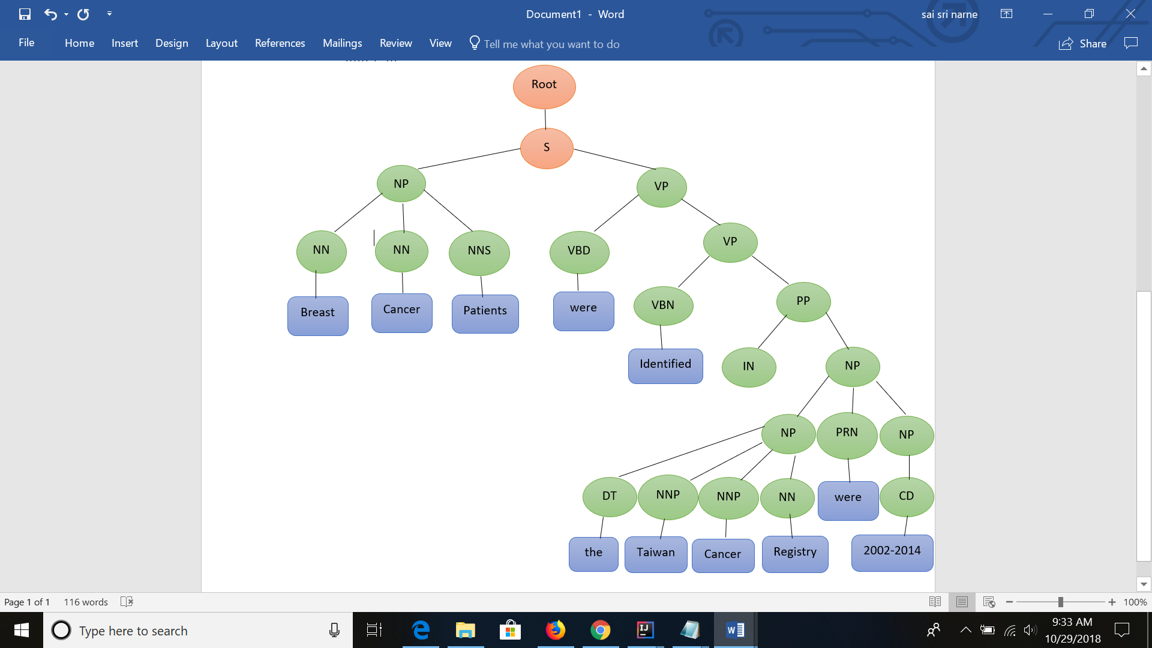

Figure : CoreNLP Basic Dependencies

2. Information Retrieval:

We use information retrieval techniques to process the data as well, namely TF-IDF and Word2Vec. These techniques do not refer to any outside sources or known sentence structures, instead analyzing the mathematically.

1. TF-IDF combines term frequency and inverse document frequency of terms in the corpus to determine which terms are relevant.
2. Word2Vec creates vectors, or dynamic arrays, by creating a co-occurrence matrix and performing single value decomposition. The resulting vectors are analyzed using cosine similarity to determine which terms in the corpus are synonymous

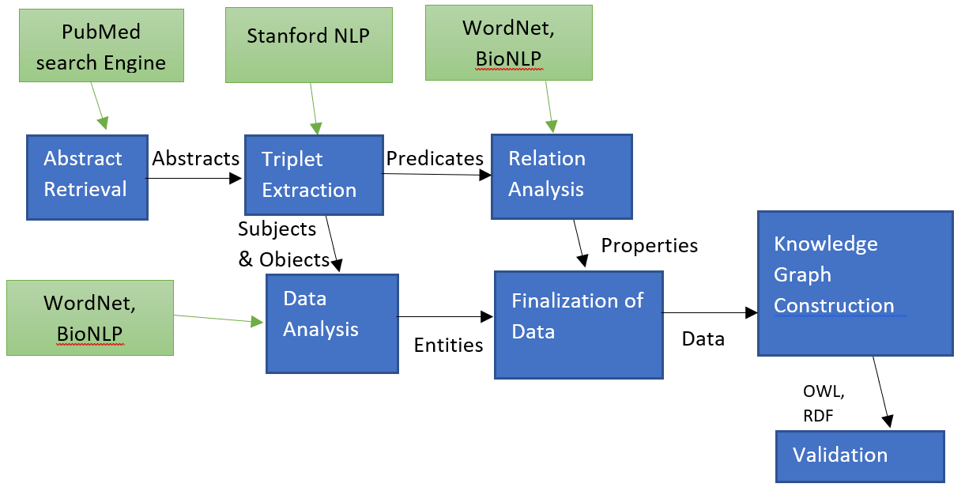

Figure : Step by step procedure and tools used

3. Knowledge graph Construction:

**Algorithms and Pseudocode:**

Much of the code for the retrieval of abstracts is done via API calls or use of NLP libraries. In particular for analysis of parts of speech and lemmatization we use the Stanford CoreNLP library and for retrieval of synonyms (prior to word2Vec) we use Rita WordNet library functions. Since Stanford CoreNLP is a Java library, we have used auxiliary scripts in Java in our Scala code.

# IV. Software &System Architecture

**Software:**

In this paper we carried our work by Intellij IDEA Community Edition 2018.2.2 environment using Scala SBT version1.0 and Spark 2.12.0 framework. Scala largely provides support for functional programming and static types making lives easier. In order to efficiently perform the operation over large corpuses we used spark framework to divide the entire corpus into small chunks of data and process it in parallel across partitions of our processing power, emulating the Hadoop distributed file system (HDFS). We set the memory and number of partitions to be used in order to utilize more of our machines resources than might otherwise be available. Notably, the pictured Spark initialization is at the head of our script which gets medical word statistics via API call.

**System Architecture:**

In-order to achieve our goal there are many preprocessing steps to be followed as in figure-2. The following are the tools used:

PubMed search engine- In the first step of figure, we used PubMedID’s to retrieve abstract text. Since, PubMed has over 28 million citations of biomedical information from MEDLINE and also a lot of journals, we used this tool to extract data. It is a free resource provides access to United States National Library of Medicine Database [8]. It is also maintained by National Center of Biotechnology Information(NCBI). This search engine makes our process to extract all the literature that contains medical information.

Stanford CoreNLP- As a part of Natural language processing, text annotation, named entity recognition, parts of speech are to be performed on the extracted text or also called to be the linguistic analysis of data, we made use of Stanford CoreNLP [9]. Stanford NLP group has come up with Stanford CoreNLP, a natural language software as their goal to make it very easy for performing linguistic analysis tools to a piece of text using pipeline. The results we got are quite interesting and also accurate mentioned in the table 1

National Center of Biotechnology Information(NCBI)- In general the medical words comprise of various categories like species, gene, chemical etc. NCBI [10], which is a part of United states of National Library of Medicine allows us to search for proteins, minerals, gene, species, chemicals etc. We made sure to find category of each word.

Table : data statistics

|  |  |  |  |  |  |  |  |  |
| --- | --- | --- | --- | --- | --- | --- | --- | --- |
| Words | Unique Words | Nouns | Verbs | Other POS | WordNet Words | Unique Wordnet Words | Medical Terms | Unique Medical Terms |
| 17267 | 3959 | 3960 | 1421 | 4289 | 8559 | 1868 | 679 | 204 |

National Center of Biomedical Ontology(NCBO)- There might be some existing list of ontologies on specific topic, NCBO [11] helped us to find the list of ontologies providing BioPortal Rest API call.

WordNet- In order to analysis more about the text data, we used WordNet. WordNet is a large lexical database of English sometimes called as a dictionary that combines nouns, verbs, adverbs, adjectives into a cognitive set of Synonyms (Synsets). We analyzed these results and compared this with Word2Vec and term frequency Id of words, shown in table 2.

Semantic Web- It is an idea of world web inventor, a mesh of data that can be processed by machines easily. Semantic web [12] makes machines work like intelligent humans. We developed W3C web ontology (OWL) to represent rich and complex knowledge about breast cancer cause, treatment, diagnosis using the extracted data.

# V. Implementation and Evaluation

We use scripts throughout the analysis of the corpus to automate the process. Currently the steps described in the proposed work section of this paper are executed by collections of scripts, however ultimately, we intend to streamline this. The scripts used are composed in a combination of Java and Scala with Spark. Thus far our corpus consists of 99 abstracts retrieved from PubMed collected automatically by providing query terms, specifically breast cancer causes, symptoms, diagnosis, and treatment. However, we have manually vetted these abstracts to some extent. First, we analyzed the corpus using NLP to get data statistics shown in table 1.

Code used to process and analyze corpus is stored at: <https://github.com/toadSTL/CS5560BreastCancerOntology>

These data statistics are obtained via spark map-reduce functions which map ‘<word>’ to ‘(<word>,1)’ for words in the corpus and then reduce by key. For part-of-Speech Statistics we use StanfordCoreNLP pipeline to annotate the data, and then do map-reduce, and similar techniques are used for WordNet word analysis and Medical term analysis.

These data statistics are not used for ontology construction, but are helpful in understanding the data which we continue to process. The next major step is to do triplet extraction on the sentences in the corpus. Our script for this reads a fresh instance of the corpus into a Spark context so that we can first perform triplet extraction.

After Information Extraction we perform Information Retrieval, performing TF-IDF on the corpus. The below image shows the code used to perform simple TF-IDF using Spark functions provided for TF-IDF. The result of TF-IDF is a matrix corresponding to the terms from the corpus.

We have several scripts to perform TF-IDF on different ‘words’ which we consider from the corpus. The above script performs TF-IDF on the words as they are in the corpus, but we also perform TF-IDF of lemmas, bigrams and trigrams. The most important words as determined by TF-IDF are then output to text files to be used by our Word2Vec scripts.

The next image shows the code of our Word2Vec script for words as they appear in the corpus. The basic strategy is to initialize the Word2Vec model using the data from the corpus. Afterward the model consists of vectors corresponding to the words from corpus and we check the cosine similarity of these vectors to determine potential synonymous terms. We output the top 3 candidates for synonyms for each of 20 most important words from the corpus as determined by TF-IDF.

The table (below) shows the synonyms found by the W2V process for the terms deemed most important or relevant to the corpus by TF-IDF:

|  |  |  |  |  |
| --- | --- | --- | --- | --- |
| Synonyms for word: PL | Synonyms for lemma: pl | Synonyms for bigram: TX stage | Synonyms for trigram: patients with PA | Synonyms for MedWord: cancer |
| treatment 0.9969 | ' 0.9969 | in patients 0.9912 | leading cause of 0.9658 | recurrent 0.9739 |
| risk 0.9968 | occur 0.9964 | of breast 0.9910 | 0.9585 | due 0.9638 |
| second 0.9967 | cancer-related 0.9963 | breast cancer 0.9909 | cause of death 0.9556 | lines 0.9539 |

As the table shows, some of the top TF-IDF terms are appropriate, but largely the synonymous terms found via Word2Vec are not. In particular “‘“ and “ “ should be removed by more thorough pre-processing of the data, but the real terms found as synonyms are perhaps indicative that we should be doing better vetting of the articles which make up our corpus.

Finally we use BioportalAPI to find terms equivalent to our medical terms from other ontologies for comparison. For each medical term from our corpus we record the number of ontologies in which that term was found in Ont_Count.txt and the the preferred label and ontology url for each corpus in which a corresponding term from our medical term was found. Ultimately a similar process will be used to evaluate our ontologies against relevant existing ontologies, like the BCS8, etc. mentioned in the related works.

# V. Conclusion

In this paper, the major work is focused on developing an ontology on breast Cancer using PubMed publications. Ontology consists of breast cancer cause, symptoms, diagnosis and treatment

# References

1. <https://ieeexplore.ieee.org/document/8217715>

1. <http://dline.info/fpaper/jdim/v15i5/jdimv15i5_3.pdf>
2. <https://arxiv.org/pdf/1607.08074.pdf>
3. <https://arxiv.org/pdf/1807.07991.pdf>
4. <https://ieeexplore-ieee-org.proxy.library.umkc.edu/document/4562013/>
5. <https://ieeexplore.ieee.org/document/6834613/>
6. <https://www.ncbi.nlm.nih.gov/pmc/articles/PMC5174013/>

[8] <https://www.ncbi.nlm.nih.gov/pubmed/>

[9] <https://stanfordnlp.github.io/CoreNLP/>

[10] <https://www.ncbi.nlm.nih.gov/>

[11] <https://bioportal.bioontology.org/>

[12] <https://www.w3.org/standards/semanticweb/>